**Exhaustive Analysis of Indian Agriculture Sector using Power BI**

**Introduction:**

Agriculture is vital to India’s economy, supporting millions of livelihoods. However, challenges like low productivity, resource inefficiency, and lack of insights hinder its growth. This project uses Power BI to create an interactive dashboard, simplifying agricultural data to help farmers, policymakers, and businesses make informed decisions. It focuses on crop production, market trends, weather impacts, and resource use, enabling better planning and sustainable development.

**Problem Statement:**

The Indian agriculture sector faces challenges like low productivity and inefficient resource use. This project uses Power BI and analytics to address these issues by:

1. Identifying top crops, states, and districts by production.
2. Analyzing seasonal and year-wise production trends.
3. Predicting production for a future year.
4. Evaluating the feasibility of Minimum Support Price (MSP) for crops.

The goal is to provide actionable insights for better resource allocation and decision-making.

**Project Description:**

* **Data Collection & Preparation:** Collect and clean data on crop yields, production areas, seasons, and market trends.
* **Data Analysis:** Analyze trends in crop yield, market conditions, and regional performance (state/district).
* **Visualization:** Create interactive Power BI dashboards to display crop production, seasonal patterns, and regional performance.
* **Actionable Insights:** Provide stakeholders with insights and recommendations to optimize agricultural resources and improve productivity.

**End Users:**

* **Farmers:** Use data insights to grow better crops and improve yields.
* **Government Officials:** Make decisions about agricultural policies and support prices.
* **Businesses:** Plan crop production and sales based on market data.
* **Researchers:** Study trends to find ways to improve farming practices.
* **NGOs:** Help farmers with resources and advice based on data analysis.

**Technology Used:**

* **Power BI:** For visualizing data.
* **Excel/SQL:** For managing and cleaning data.
* **Data Sources:** Kaggle
* **Tools:** Power BI Desktop

**Questions:**

* Which state has the highest agricultural production?
* What are the top 5 crops that occupy the most area?
* How does crop production vary across different seasons?
* What is the average yield per area for different crops?
* Which crops show the highest production across different years?
* What factors influence crop yield and production in each district?
* How does the crop area change from one season to another?
* What are the trends in crop production from 2010 to 2019?
* Which crops are produced most in each season?
* How can we optimize agricultural resources based on the yield and production data?

**Results:**

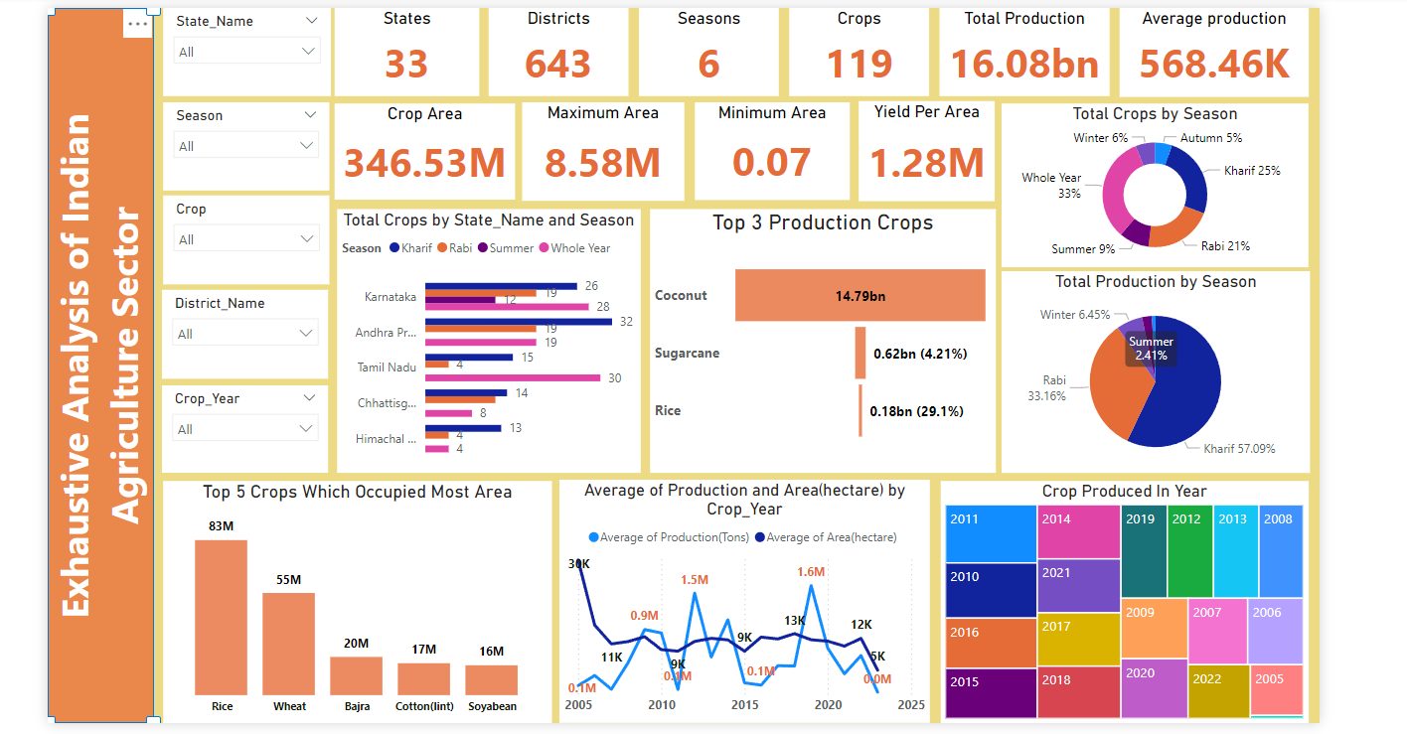

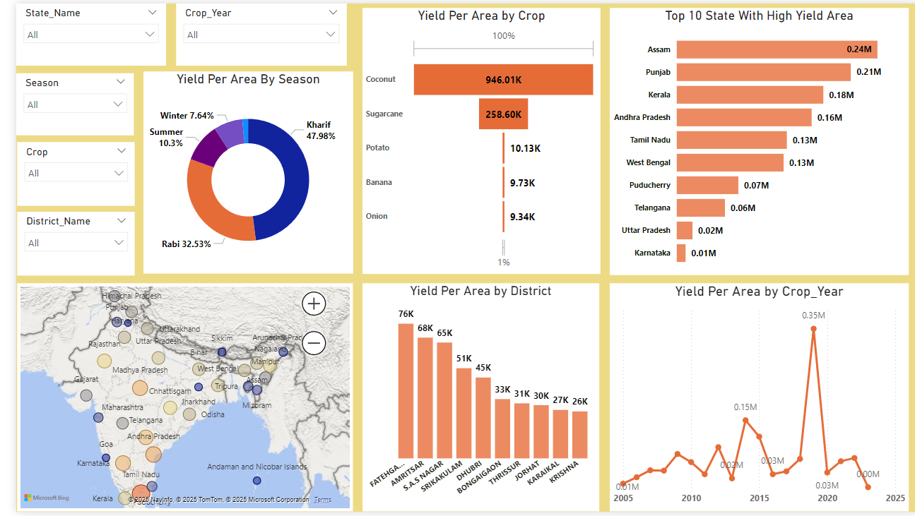

**Future Scope:**

* **Predictive Analytics:** Use advanced models to predict crop yields, market prices, and other key factors.
* **Education and Training:** Offer learning resources to help farmers use data and technology in their work.
* **Enhanced Data Integration:** Add more data, like weather and soil conditions, to make predictions more accurate.

**Conclusion:**

The analysis of agricultural data reveals significant insights into crop production, distribution, and trends across various states and districts. Key findings indicate that sugarcane occupies the most area and leads in production, while crop yields vary by season and region. The data shows that production is influenced by seasonal patterns, with variations in crop yields from year to year. By understanding these trends, policymakers, farmers, and agricultural businesses can make informed decisions to optimize resources, improve yield, and enhance sustainability. Future efforts can focus on precision agriculture, predictive analytics, and integrating additional data sources to drive further improvements in productivity and efficiency.